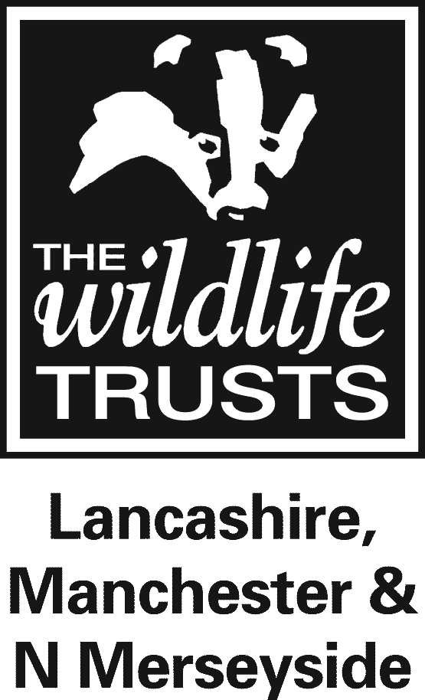

The Wildlife Trust for Lancashire, Manchester and North Merseyside

ORGANISATIONAL COVID-19 RISK ASSESSMENT

Areas Assessed | All Trust Activities |  | Assessor | Ben Turpin (SHE Advisor) | Published | 10th December 2021
Statement
This risk assessment is designated to inform readers of the general measures Lancashire Wildlife Trust (LWT) will be employing in order to minimize the risk of Covid-19 transmission on all sites and during its activities and has been updated to reflect changes to restrictions as announced on 08/12/2021.

Supporting Documentation
LWT First Aid and Coronavirus Guidance_V2
LWT Hygiene and Sanitation in the Workplace Guidance_V4
LWT Covid-19 & Vehicles Guidance_V3
LWT Coronavirus PPE_V3
LWT Risk Assessments for Indoor Workplaces, Outdoor Work and Volunteering, Venue Hire & Catering

Pre-requisites
- A Covid-19 team has been established and meets on a regular basis to discuss changing circumstances and make key decisions (regularity depends on risk level)
- General Risk Assessments will be in place that cover all operations of the Trust (e.g. Offices, Volunteering, Meetings, Public Events, etc.)
- The term ‘Staff’ will refer to both paid employees and volunteers
- This and internal risk assessments will be reviewed at frequencies as government guidance and other circumstances change
- All staff and visiting public must not to come onto Trust sites if they are displaying symptoms of COVID-19 or told to self-isolate
- Staff must report any Covid-19 near misses (confirmed risk of transmission), instruction to self-isolated, infections, symptoms and testing they are subjected to
- Staff are encouraged to take twice weekly Lateral Flow Tests and especially in the morning of leading any group activity
- Staff are encouraged to follow government guidance in relation to the vaccination programme

Activity/ Scenario |  | Virus Transmission | Controls and Procedures
Indoor Work  (Offices, Workshops, Welfare Facilities) |  | Airborne | - Indoor workplaces will be supported by the Indoor Work Risk Assessment  - All staff who are able to work from home should do so from Monday 13th December. Offices will remain open as some business critical tasks  - Staff who are in offices should maintain a minimum of 2m social distancing  - In-person team meetings should not happen. One-to-one in-person meetings should also not happen unless for business critical purposes  - Job interviews should be held online (e.g. Microsoft Teams)  - Workstations and seating for staff meetings must be placed 2m apart where possible or use a separation screen  - Where social distancing cannot be achieved, staff should wear a face covering to reduce the risk of airborne transmission.  - Staff should wear face coverings indoors until seated  - Areas and activities throughout the Trust will follow the best fit risk general risk assessment  - Staff should be assessed for vulnerabilities using return to work/volunteering assessments  - Appropriate signs and risk assessments will be in place reminding those present of the risks and measures to reduce  - First aid staff are provided with guidance for managing coronavirus risks and are provided mask and gloves to reduce transmission during treatment: LWT First Aid and Coronavirus Guidance_V2  - Staff are encouraged to use NHS QR Codes that are displayed throughout the Trust to support NHS Test and Trace  - Windows and doors should be opened to help improve ventilation
 |  | Contact Surfaces | - Cleaning equipment and procedures should be available and followed for each working environment: LWT COVID-19 – Hygiene and Sanitation in the Workplace Guidance_V4  - Staff will be provided with and encouraged to use washing facilities and hand sanitizing products  - Doors should remain open where possible to remove contacts points. Fire doors will remain shut to comply with regulations  - Staff should be assigned work stations if they return to offices full time or have hybrid working arrangements. Hot desks will be provided for staff who have irregular office working patterns.  - Signs and Risk Assessments will be displayed reminding those present of the risks and management measures in place  - First aid staff are provided with guidance for managing coronavirus risks and are provided mask and gloves to reduce transmission during treatment: LWT First Aid and Coronavirus Guidance_V2
Activity/ Scenario |  | Virus Transmission | Controls and Procedures
Outdoor Work and Volunteering (conservation and maintenance) |  | Airborne | - Outdoor activities will be supported by the Outdoor Work and Volunteering Risk Assessment  - Staff should maintain a minimum of 2m social distancing  - Where social distancing cannot be achieved, staff should wear a face covering to reduce the risk of airborne transmission.  - A maximum of 15 volunteers should be invited to work parties. More can be invited if deemed essential by the leader  - First aid staff are provided with guidance for managing coronavirus risks and are provided mask and gloves to reduce transmission during treatment: LWT First Aid and Coronavirus Guidance_V2
 |  | Contact Surfaces | - Work equipment can be shared but must be sanitized before use  - Cleaning equipment and procedures should be set in place and followed for each working environment: LWT COVID-19 – Hygiene and Sanitation in the Workplace Guidance_V4  - Staff will be provided and must use washing facilities and hand sanitising products  - Signs will be displayed at key points advising visitors to socially distance and to sanitise their hands if they have been inside hides, viewing screens or used carpark machines  - First aid staff are provided with guidance for managing coronavirus risks and are provided mask and gloves to reduce transmission during treatment: LWT First Aid and Coronavirus Guidance_V2
Activity/ Scenario |  | Virus Transmission | Controls and Procedures
Events, Retail & Catering |  | Airborne | - Catering facilities will be provided with a general Covid-19 risk assessment  - Covid-19 signs will be displayed to the public to encourage adherence to restrictions  - Public must wear face coverings while indoors until seated (via poster). Staff will not be expected to challenge public non-compliance  - When public facing and front of shop, Staff must wear face coverings. Screens will remain in place by service counters to create a physical barrier between staff and customers  - First aid staff are provided with guidance for managing coronavirus risks and are provided mask and gloves to reduce transmission during treatment: LWT First Aid and Coronavirus Guidance_V2  - NHS QR Codes will be displayed at all catering sites  - Face coverings should be made available to the public to encourage compliance  - Staff in charge of events should monitor numbers and behaviour and introduce measures if social distancing becomes difficult.
 |  | Contact Surfaces | - Cleaning regimes will be put in place for kitchen and customer areas as aligned with HACCP practices  - Card transactions will be encouraged  - Hand sanitizer will be offered to customers at queues or entry to buildings  - Doors will remain open to reduce the need of contact and aid ventilation, unless they are fire doors  - First aid staff are provided with guidance for managing coronavirus risks and are provided mask and gloves to reduce transmission during treatment: LWT First Aid and Coronavirus Guidance_V2
Activity/ Scenario |  | Virus Transmission | Controls and Procedures
Travel |  |  | - Car sharing should only be done when there is no realistic alternative and the travel is business critical  - Vehicle sharing guidance is set out in LWT Covid-19 and Vehicles_V3

